Steps for testing:

1. Project target framework is 7.0 core
2. Build the project and see the output for message
3. If you have redis server then just change the connection under appsetting.config file
4. Else if you don’t have use following method for testing
5. If it’s successfully build then install the Redis Server. I have setup the redis on my local window machine by following way
6. I have download the redis from this link <https://github.com/microsoftarchive/redis/releases/tag/win-3.0.504>
7. Will look like this

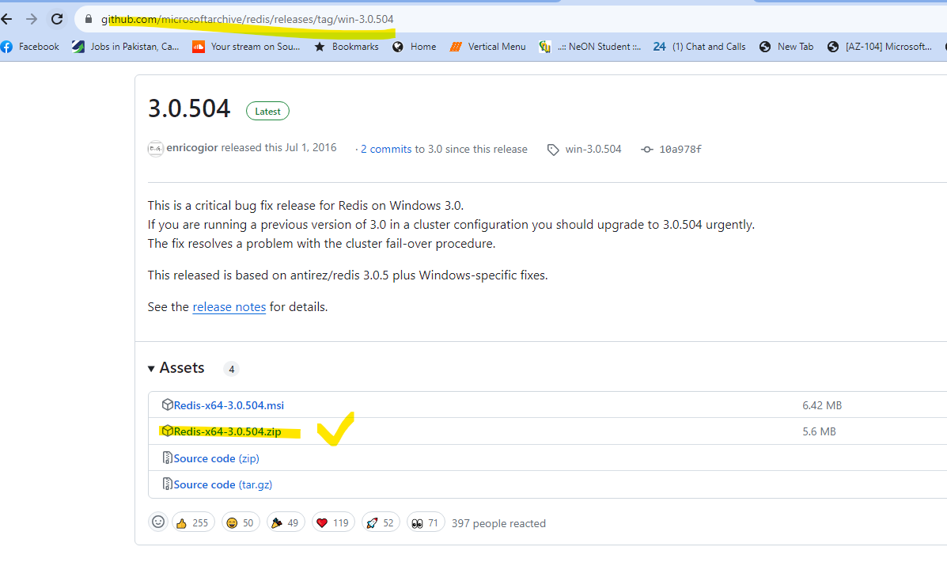

1. After download and extraction it will looks like this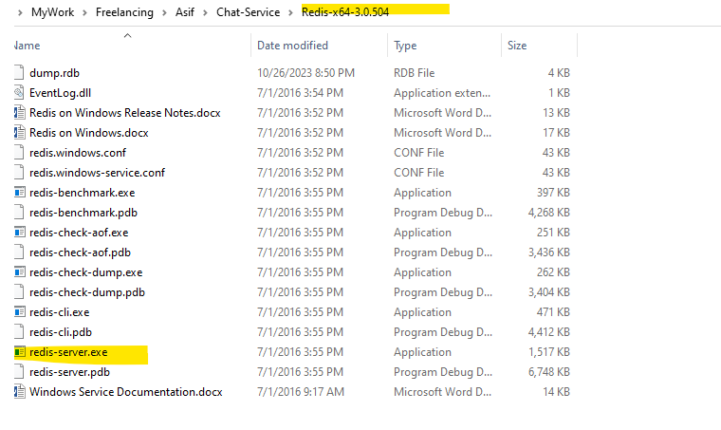
2. Then run this exe by cmd using this command

Path>redis-server.exe

1. After run will look like this 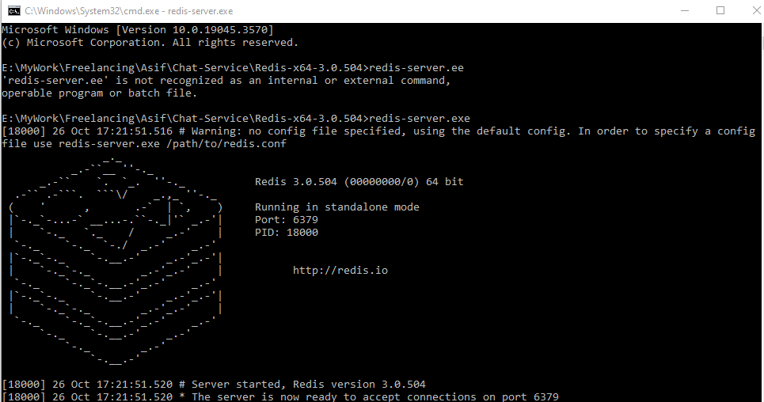
2. Now redis server is ready
3. Run the project and you can test